Wipro stock prediction using LSTM

*Note: Sub-titles are not captured in Xplore and should not be used

PRABHASH RANJAN  
Data Science,Noida institute of Engineering and TechnologyGautambudh Nagar GR, India  
  
0201csds044@niet.co.in  
 NAMAN GUPTA  
Data Science, Noida institute of Engineering and TechnologyGautambudh Nagar GR, India  
  
[0201csds0174@niet.co.in](mailto:0201csds0174@niet.co.in)

ASHRAF  
Data Science, Noida institute of Engineering and TechnologyGautambudh Nagar GR, India  
  
[0201csds044@niet.co.in](mailto:0201csds044@niet.co.in)

*Abstract*—The aim is to predict the future value of the financial stocks of WIPRO. The future prediction is done using previous data and using that data a machine learning model is trained which analyses the trend based on its learning outputs the result. This paper focuses on use of regression, minmaxscaler and LSTM based Machine learning to predict stock values.

Keywords--Close, high, low, LSTM model, minmaxscaler, open, regression, and volume.

# Introduction

Big companies or financial institutions hires thousand of peoples to find pattern and predict stock price and make profit. It is difficult for them to manage and evaluate with so many factors for proper prediction and finding the trend. This work can easily be performed using machine learning model and this model can save a huge amount of money and can do much better prediction with greater accuracy and with keeping all variable factors in mind.

Keeping this in mind and finding how much money making it can be. a lot of research is being done in this field and people are constantly trying to improve the model by applying various model training algorithm. In this advent we also have tried to implement and improve the model by using LSTM (long short term memory).

Now if we are talking about the accuracy then there are many factors which affect the price of a stock of a company. Maybe it is due to short term company’s policy or maybe it is because of some action taken by some high-ranking officer or the possibilities or causes are endless and it is really hard and difficult to keep all the parameters in mind while solving the problem that is predicting the trend.

Despite of all this factors one major thing that contributes how model will perform is on what dataset the model is trained .and selecting the proper dataset is very important. Sometime even if people select the right dataset, then also, they take wrong time interval from which they must train the model. For example, if you want to predict short term then you should not train model with long term dataset. The model will skip short term prediction and if model is trained on relatively short-term data, then the model will have insufficient data to learn from and it will not perform up to the mark as expected.

So keeping all this factors in mind we have picked Wipro stock market dataset from Yahoo Finance. The dataset consist of various variables such as: prev close, open, high, low, last, close, volume. And each contain stock price of stock of various time. Volume contains information of stock data and amount of stock traded from one owner to another.

The dataset is divided into two parts one is train data and other is test data. Regression and LSTM models are engaged for this conjecture separately. Regression minimizes the loss and LSTM remembers the data for long term prediction.

# RELATED WORK

Hello

# METHODOLOGY

It is difficult to predict the stock valuation and stock price in future and with proper accuracy can be tricky work to do, so we are using AI and machine learning model to learn from previous dataset and predict the trend of the market or stock with better accuracy. For training the model the dataset plays an important role, so for that reason we have taken the data from Yahoo finance. The dataset comprises of stock value from year 2000 to 2021 and contains about 5300 entries which consist of previous closing rate, open, high, low, last, close volume, turnover, trades and many essential data. We have converted it into data-frame using pandas. We have split the dataset into train and test data set in ratio 80 to 20 respectively.

Although machine learning has many algorithms for prediction but we would like to stick with LSTM. We are using LSTM because as its name suggest it remembers long as well as short term memory.

*A. Long Short Term Memory (LSTM) Network Based Model*

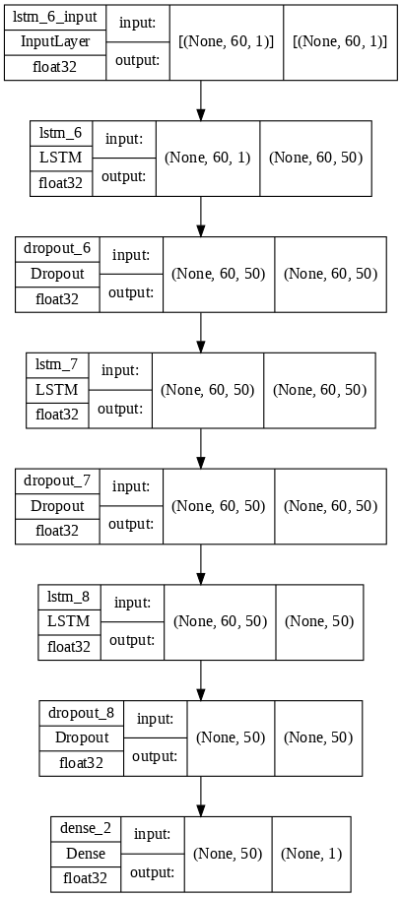

Fig.1 LSTM Layers

LSTM is the advanced model of Recurrent-Neural Networks (RNN) in which the information belonging to preceding state persists. these are distinct from RNNs as they contain long time dependencies and RNNs works on locating the relationship between the latest and the current information. This suggests that the interval of information is quite smaller than that to LSTM. the principle cause behind using this model in stock market prediction is that the predictions depends on huge amounts of records and are generally depending on the long-time records of the marketplace. So LSTM regulates errors by means of giving an resource to the RNNs thru retaining records for older tiers making the prediction more accurate. for this reason proving itself as plenty extra reliable in comparison to different strategies. considering the fact that stock market involves processing of massive data, the gradients with respect to the weight matrix may additionally turn out to be very small and can degrade the learning fee. The corresponds to the problem of Vanishing Gradient. LSTM prevents this from happening. The LSTM consists of a remembering cell, input gate, output gate and a forget gate. The cell remembers the value for long term propagation and the gates regulate them.

In this paper we have made a sequential model consisting of four layers of LSTM stacked over one another and a with the output value as mentioned in Fig. 1. each and at last a dense layer is created where each neuron is connected to every other neuron and it takes input of 50 and gives an output of 1. Additionally, we have also created dropout layer with 0.2 percent of dropout in every layer, this will prevent the model from over fitting which is a major drawback while training the model. The model is compiled with mean square cost function to maintain the error and loss.

We have taken 25 epochs with batch size of 32 and for time series we have saved data by using callback method and saving progress and using tensorboard to visualize it.

# Experiment Result

The trained model is trained and tested as in proposed dataset.

We have taken the dataset of Wipro Limited from yahoo finance and split it as it was proposed.

## LSTM based model result

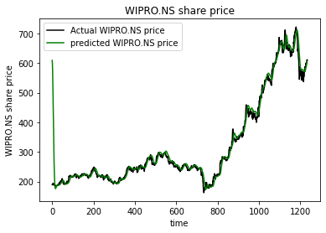

Fig. plot between actual and predicted stock prices

The black line denotes the actual wipro stock prices in this timeframe while the green line predicts the price of wipro stock predicted by the respective trained model prescribed above. The distance between the two lines shows how much efficient the LSTM model is. The model resulted the RMSE(root mean square error) of 29.131674 when actual price vs predicted price is calculated.

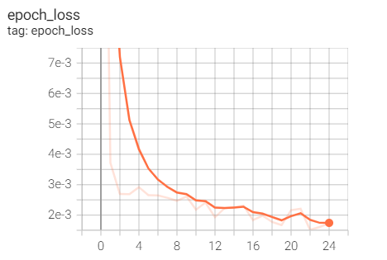

Fig 3. Epoch vs loss

The above fig 3. Show epoch vs loss data. We have just taken 25 epochs because that concluded us with very little loss in training thus providing high accuracy than another model such as RNN.

# Conclusion

This paper was an attempt to make model and try to predict the price with better accuracy and less RMSE score. The model was a conclusion of the LSTM model that we have used in this paper. The techniques have shown positive development in predicting future prices of various stock prices of various companies. The LSTM model is quite good and efficient.

Our future goals are to make the model more accurate will try to tweak the model with more parameters and will try to provide more dataset to get trained. Our future goal is to make a model with higher accuracy and efficiency not only this we will try to implement other factors which affect stock market like news circulating about a company or organization and based on the sentiment predicting what would be the output of it.

##### Acknowledgment *(Heading 5)*

The preferred spelling of the word “acknowledgment” in America is without an “e” after the “g”. Avoid the stilted expression “one of us (R. B. G.) thanks ...”. Instead, try “R. B. G. thanks...”. Put sponsor acknowledgments in the unnumbered footnote on the first page.

##### References

The template will number citations consecutively within brackets [1]. The sentence punctuation follows the bracket [2]. Refer simply to the reference number, as in [3]—do not use “Ref. [3]” or “reference [3]” except at the beginning of a sentence: “Reference [3] was the first ...”

Number footnotes separately in superscripts. Place the actual footnote at the bottom of the column in which it was cited. Do not put footnotes in the abstract or reference list. Use letters for table footnotes.

Unless there are six authors or more give all authors’ names; do not use “et al.”. Papers that have not been published, even if they have been submitted for publication, should be cited as “unpublished” [4]. Papers that have been accepted for publication should be cited as “in press” [5]. Capitalize only the first word in a paper title, except for proper nouns and element symbols.

For papers published in translation journals, please give the English citation first, followed by the original foreign-language citation [6].

1. G. Eason, B. Noble, and I. N. Sneddon, “On certain integrals of Lipschitz-Hankel type involving products of Bessel functions,” Phil. Trans. Roy. Soc. London, vol. A247, pp. 529–551, April 1955. *(references)*
2. J. Clerk Maxwell, A Treatise on Electricity and Magnetism, 3rd ed., vol. 2. Oxford: Clarendon, 1892, pp.68–73.
3. I. S. Jacobs and C. P. Bean, “Fine particles, thin films and exchange anisotropy,” in Magnetism, vol. III, G. T. Rado and H. Suhl, Eds. New York: Academic, 1963, pp. 271–350.
4. K. Elissa, “Title of paper if known,” unpublished.
5. R. Nicole, “Title of paper with only first word capitalized,” J. Name Stand. Abbrev., in press.
6. Y. Yorozu, M. Hirano, K. Oka, and Y. Tagawa, “Electron spectroscopy studies on magneto-optical media and plastic substrate interface,” IEEE Transl. J. Magn. Japan, vol. 2, pp. 740–741, August 1987 [Digests 9th Annual Conf. Magnetics Japan, p. 301, 1982].
7. M. Young, The Technical Writer’s Handbook. Mill Valley, CA: University Science, 1989.

**IEEE conference templates contain guidance text for composing and formatting conference papers. Please ensure that all template text is removed from your conference paper prior to submission to the conference. Failure to remove template text from your paper may result in your paper not being published.**